**Requirements specification for Sharing business process**

1. General description of business process

1. A general description of the business process and a description of the performance metrics generated by this process, possible current analytical problems.

The process of sharing a car is as follows: the customer downloads the CarShare app, creates an account with a linked credit/debit card. Next, the customer finds a nearby car to rent it for a ride, all of the available cars are shown on the map in the app. After the customer has chosen a car, he confirms his choice, the car unlocks itself and is ready to be driven. After the customer has reached the planned destination, he confirms the end of the ride in the valid area for parking (visible in the app), linked bank account is charged appropriately to time spent in the CarShare vehicle. The car is locked and ready to use for the next customer, if there is enough petrol for average ride distance.

After payment these metrics are generated:

location of starting and finishing points of the travel, time in which the distance was traveled, total distance, information regarding if the user had a subscription, type of car rented, how much a customer was charged, cars VIN number, the date of travel.

**The increase of rentals of cars in each city by at least 1% each month compared to previous month.**

**The annual increase in profit by 7% in total (from all locations).**

1. Typical questions

What are the most popular car models used by customers?

What is the average distance traveled by customers?

What is the average cost of a ride?

What is the average occupancy rate of the cars?

What is the most popular type of car rented?

Which cities have the highest number of rentals?

What are the busiest times of day or week for car sharing rentals?

What is the average age of customers?

What is the average money spent by a customer monthly?

What is the average duration of a ride?

What is the average rating?

1. Data

Data is stored in the databases connected with the CarShare app.

2. Data sources structures

***Database***

| TABLE NAME | ATTRIBUTE | ATTRIBUTE TYPE | DESCRIPTION |
| --- | --- | --- | --- |
| CAR | VIN_number (PK) | varchar (17 characters) | Unique identification number for each car |
| make | varchar (50 characters) | Brand name of the vehicle |
| model | varchar (50 characters) | Model of the vehicle |
| prod_year | int | Year of production of the vehicle |
| engine_power | int | Horsepower of the engine |
| type | varchar (50 characters) | Type of vehicle (sedan, SUV, hatchback, etc.) |
| USER | user_id (PK) | int | Unique identification number for each user |
| user_name | varchar (50 characters) | Name of the user |
| email | varchar (50 characters) | Email address of the user |
| phone | varchar (15 characters) | Phone number of the user |
| age | int | Age of the user |
| gender | varchar (10 characters) | Gender of the user |
| RENTAL | rental_id (PK) | int | Unique identification number for each rental |
| VIN_number (FK) | varchar (17 characters) | VIN number of the car that was rented |
| user_id (FK) | int | User ID of the user who rented the car |
| city_id (FK) | int | Unique identification number for each city |
| start_time | datetime | Start time of the rental |
| end_time | datetime | End time of the rental |
| date | date | Date of the rental |
| cost | int | Cost of the rental |
| distance | int | distance traveled |
| PAYMENT | payment_id (PK) | int | Unique identification number for each payment |
| rental_id (FK) | int | User ID of the user who made the payment |
| amount | int | Amount of the payment |
| date | date | Date of the payment |
| method | varchar (20 characters) | Payment method (credit card, cash, etc.) |
| CITY | city_id (PK) | int | Unique identification number for each city |
| city_name | varchar (50 characters) | Name of the city |
| voivodeship | varchar (50 characters) | Voivodeship/province of the city |
| population | int | Population of the city |
| area | int | Area of the city |
| WEATHER | wheather_id (PK) | int | Unique identification number for each day in each city |
| city_id (FK) | int | identification number for each city |
| clouds | percentage | clouds in percentage |
| rain | percentage | rain percentage |
| average temperature | int | average temperature recorded |
| date | date | Date of measurement |
| EQUIPMENT | equipment_id (PK) | int | Unique identification number for one entry |
| VIN_number (FK) | varchar (17 characters) | identification number for each car |
| heated_seats | int | "1" or "0", "1" if the car is equipped with this option, zero otherwise |
| ventilated _seats | int | "1" or "0", "1" if the car is equipped with this option, zero otherwise |
| ABS | int | "1" or "0", "1" if the car is equipped with this option, zero otherwise |
| ASC | int | "1" or "0", "1" if the car is equipped with this option, zero otherwise |
| Air_conditioning | int | "1" or "0", "1" if the car is equipped with this option, zero otherwise |
| GPS | int | "1" or "0", "1" if the car is equipped with this option, zero otherwise |
| Android_Auto | int | "1" or "0", "1" if the car is equipped with this option, zero otherwise |
| Apple_carplay | int | "1" or "0", "1" if the car is equipped with this option, zero otherwise |
| transmission | int | "1" or "0", "1" if the car is equipped with this option, zero otherwise |

***ERD***

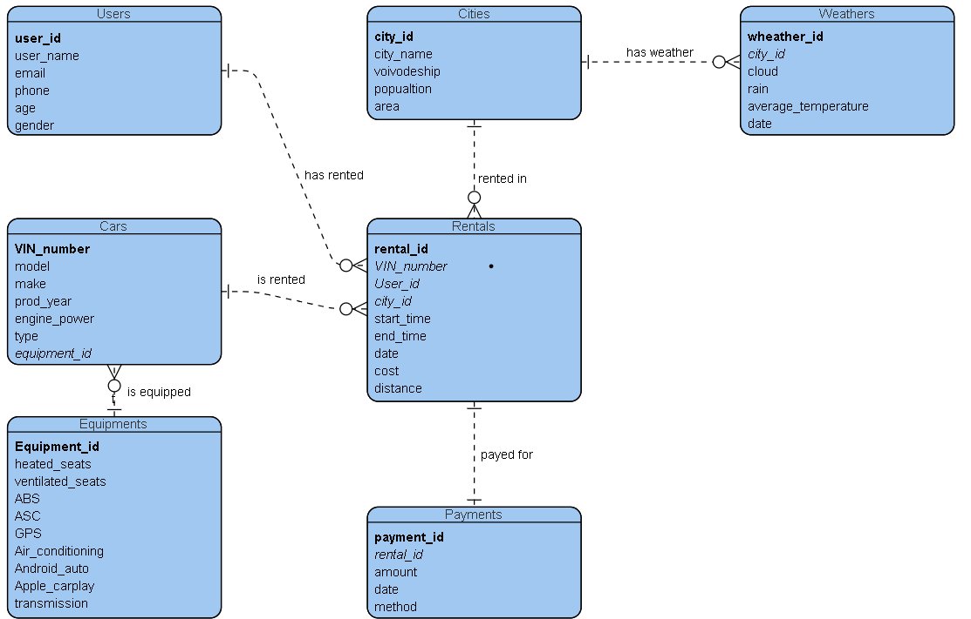

***Excel***

Information about ratings regarding car model in a specific city

* COLUMN A - rating (int, from 1 to 5)
* COLUMN B - VIN_number (text, 17 characters)
* COLUMN C - date of rental (date)
* COLUMN D - city (text)

3. Scenarios of analytical problems

*How do different regions affect the type of car needed by customers?*

1. Compare the models of cars by their total rentals in different cities.
2. Compare total rentals in cities with the ratio of total cars in a city to the population.
3. Compare total rentals in cities with the ratio of total cars in a city to the area.
4. Compare the amounts of rentals in winter and summer in different cities.
5. What models are rented for the longest distance travels?
6. Compare average rating of car model from excel spreadsheet to amount of rentals in given city.
7. Compare ratings of different models in different cities.
8. Compare male to female ratio with the amount of rentals in different cities.

*Why is there a decrease/increase in car rentals this month?*

1. Compare the number of rentals of different car models in current and previous month.
2. Compare the total number of rentals in different cities monthly.
3. What is the impact of rainfall in car rentals monthly?
4. Compare ratings from this month of each model to the ratings from previous month.
5. *What is the ratio of “reserved and rented” to “rented without reservation” rentals?*
6. *Compare the number of reports about cars from this month to the previous month.*
7. What is the equipment that appears in cars with the most rentals in different months?
8. Compare the ratio of rentals to the sum of the amounts paid by customers in different months.

4. Data needed for analytical problems

**Analytical problem:** *How do different regions affect the type of car needed by customers?*

1. Compare the models of cars by their total rentals in different cities.
   * ***car models*** - Database, table Cars, column model
   * ***number of rentals*** - Database, table Rentals, columns city_id and rental_id
   * ***city name*** - Database, table Cities, column city_name
2. Compare total rentals in cities with the ratio of total cars in a city to the population.
   * ***number of cars*** - Database, table Cars, column VIN_number
   * ***city name*** - Database, table Cities, column city_name
   * ***population*** - Database, table Cities, column population
   * ***total rentals*** - Database, table Rentals, column rental_id
3. Compare total rentals in cities with the ratio of total cars in a city to the area.
   * ***city name*** - Database, table Cities, column city_name
   * ***city area*** - Database, table Cities, area
   * ***number of cars*** - Database, table Cars, column VIN_number
   * ***total rentals*** - Database, table Rentals, column rental_id
4. Compare the amounts of rentals in winter and summer in different cities.
   * ***season*** - Database, table Rentals, column date
   * ***city name*** - Database, table Cities, column city_name
5. What models are rented for the longest distance travels?
   * ***longest distances*** - Database, table Rentals, column distance (50 longest results)
   * **car models** - Database, table Cars, column model
6. Compare average rating of car model from excel spreadsheet to amount of rentals in given city.
   * ***average rating in each month*** - Excel, columns rating and VIN_number
   * **car models** - Database, table Cars, column model
   * ***number of rentals*** - Database, table Rentals, columns city_id and rental_id
7. Compare ratings of different models in different cities.

* ***average rating for each model*** - Excel, columns rating and VIN_number
* **car models** - Database, table Cars, column model
* **cities** - Database, table cities, column city_name

**Analytical problem:** *Why is there a decrease/increase in car rentals this month?*

1. Compare the number of rentals of different car models in current and previous month.

* ***number of rentals in each month*** - Database, table Rentals, columns rental_id and date
* ***different car models*** - Database, table Cars, columns VIN_number and model

1. Compare the number of rentals in different cities monthly.

* ***number of rentals monthly*** - Database, table Rentals, columns rental_id and date
* ***different cities*** - Database, table Cities, column city_name

1. What is the impact of rainfall in car rentals monthly?

* ***number of rentals monthly*** - Database, table Rentals, columns rental_id and date
* ***rainfall percentage*** - Database, table Weathers, columns rain and date

1. Compare ratings from this month of each model to the ratings from previous month.

* ***average rating in each month*** - Excel, columns rating and VIN_number
* ***car models*** - Database, table Cars, columns VIN_number and model

1. *What is the ratio of “reserved and rented” to “rented without reservation” rentals?*

* ***reservations*** - no such information, requires changes in business process
* ***number of rentals*** - Database, table Rentals, column rental_id

1. *Compare the number of reports about cars from this month to the previous month.*

* ***number of reports*** - no such information, new datasource required
* ***cars*** - Database, table Cars, column VIN_number

1. What is the equipment that appears in cars with the most rentals in different months?

* **equipment** - Database, table Equipments, columns *
* **most rented cars** - Database, table Rentals, columns rental_id
* **cars** - Database, table Cars, columns VIN_number

1. Compare the ratio of rentals to the sum of the amounts paid by customers in different months.

* **number of rentals** - Database, table Rentals, column rental_id
* **sum of amounts paid** - Database, table Payments, column amounts, date

It is not possible to build BI system to solve given analytical problems without introducing additional activities to the business process. It is suggested to add the possibility of reserving cars when they are not being used before renting them, as well as adding a way for a user to report a damage on the cars.

Reservations should be added into the database with attributes: reservation_id (PK), date, start_time, end_time, VIN_number (FK), user_id (FK), rental_id (FK).

Reports could be saved in a Excel file with structure:

* COLUMN A - VIN_number (text, 17 characters)
* COLUMN B - name of damaged part (text)
* COLUMN C - date (date)
* COLUMN D - users description (text, up to 200 characters)

To report a damage user should be able to use a prepared questionnaire for every car built in the app. User should enter the data in form similar to the following one:

1. What is the name of the damaged part?
2. Give a brief description of the damage. (up to 200 characters).

VIN_number and date should be collected from the app automatically.